Adam Gascoyne

03/13/22

ADVANCED DATA MANAGEMENT - D191:

**Business Question:** In this project I will be answering the question of “What rating is most prevalent in “inventory”, and what is the total amount of films in “inventory”?

**A1-A6:** The data we will be using is the rating data for totaling the number of DVDs in inventory and to total how many DVDs fall into each categorical rating (G, PG, PG-13, R, NC-17). The data used was from two tables: the film and inventory table. The detailed table will receive the fields of rating (film table) and film_id (film and inventory table) and inventory_id (inventory table). The summary table will hold the data for totals of each rating and total DVD amount. The columns for summary thus will be g_rating_tot, pg_rating_tot, pg13_rating_tot, r_rating_tot, nc17_rating_tot, and total_dvds. To get the totals for each rating we will have to transform the singular data for rating of each DVD, which is in a varchar form, to a total of each rating, which is in integer form. If a rating is 'G' for example, it will be counted into a total for 'G' rated movies into the summary table under the g_rating_tot. Also, the total amount of DVDs will be found from counting all rows from the detailed table. The benefit of the detailed table is that it shows the specific rating for each specific DVD. The benefits of the summary table are that it simply shows the total amount of DVDs that are in inventory, allowing the business to see if they are becoming limited on their DVD inventory. It also could show which DVD rating is most prevalent or least prevalent. This shows that either they need to order more a rating or possibly that a rating is more popular than another. This report could be done once a month to see changes in total DVDs and rating totals, which helps show trends by month, such as which rating is most popular and which months are the lowest/highest rate for renting.

**B:** This code creates a new table called “detailed” and if it already exists, deletes it, and creates it again. The first picture shows successful code. The second picture shows the actual table with the columns of inventory_id, film_id, and rating using the “SELECT * FROM detailed;” code.

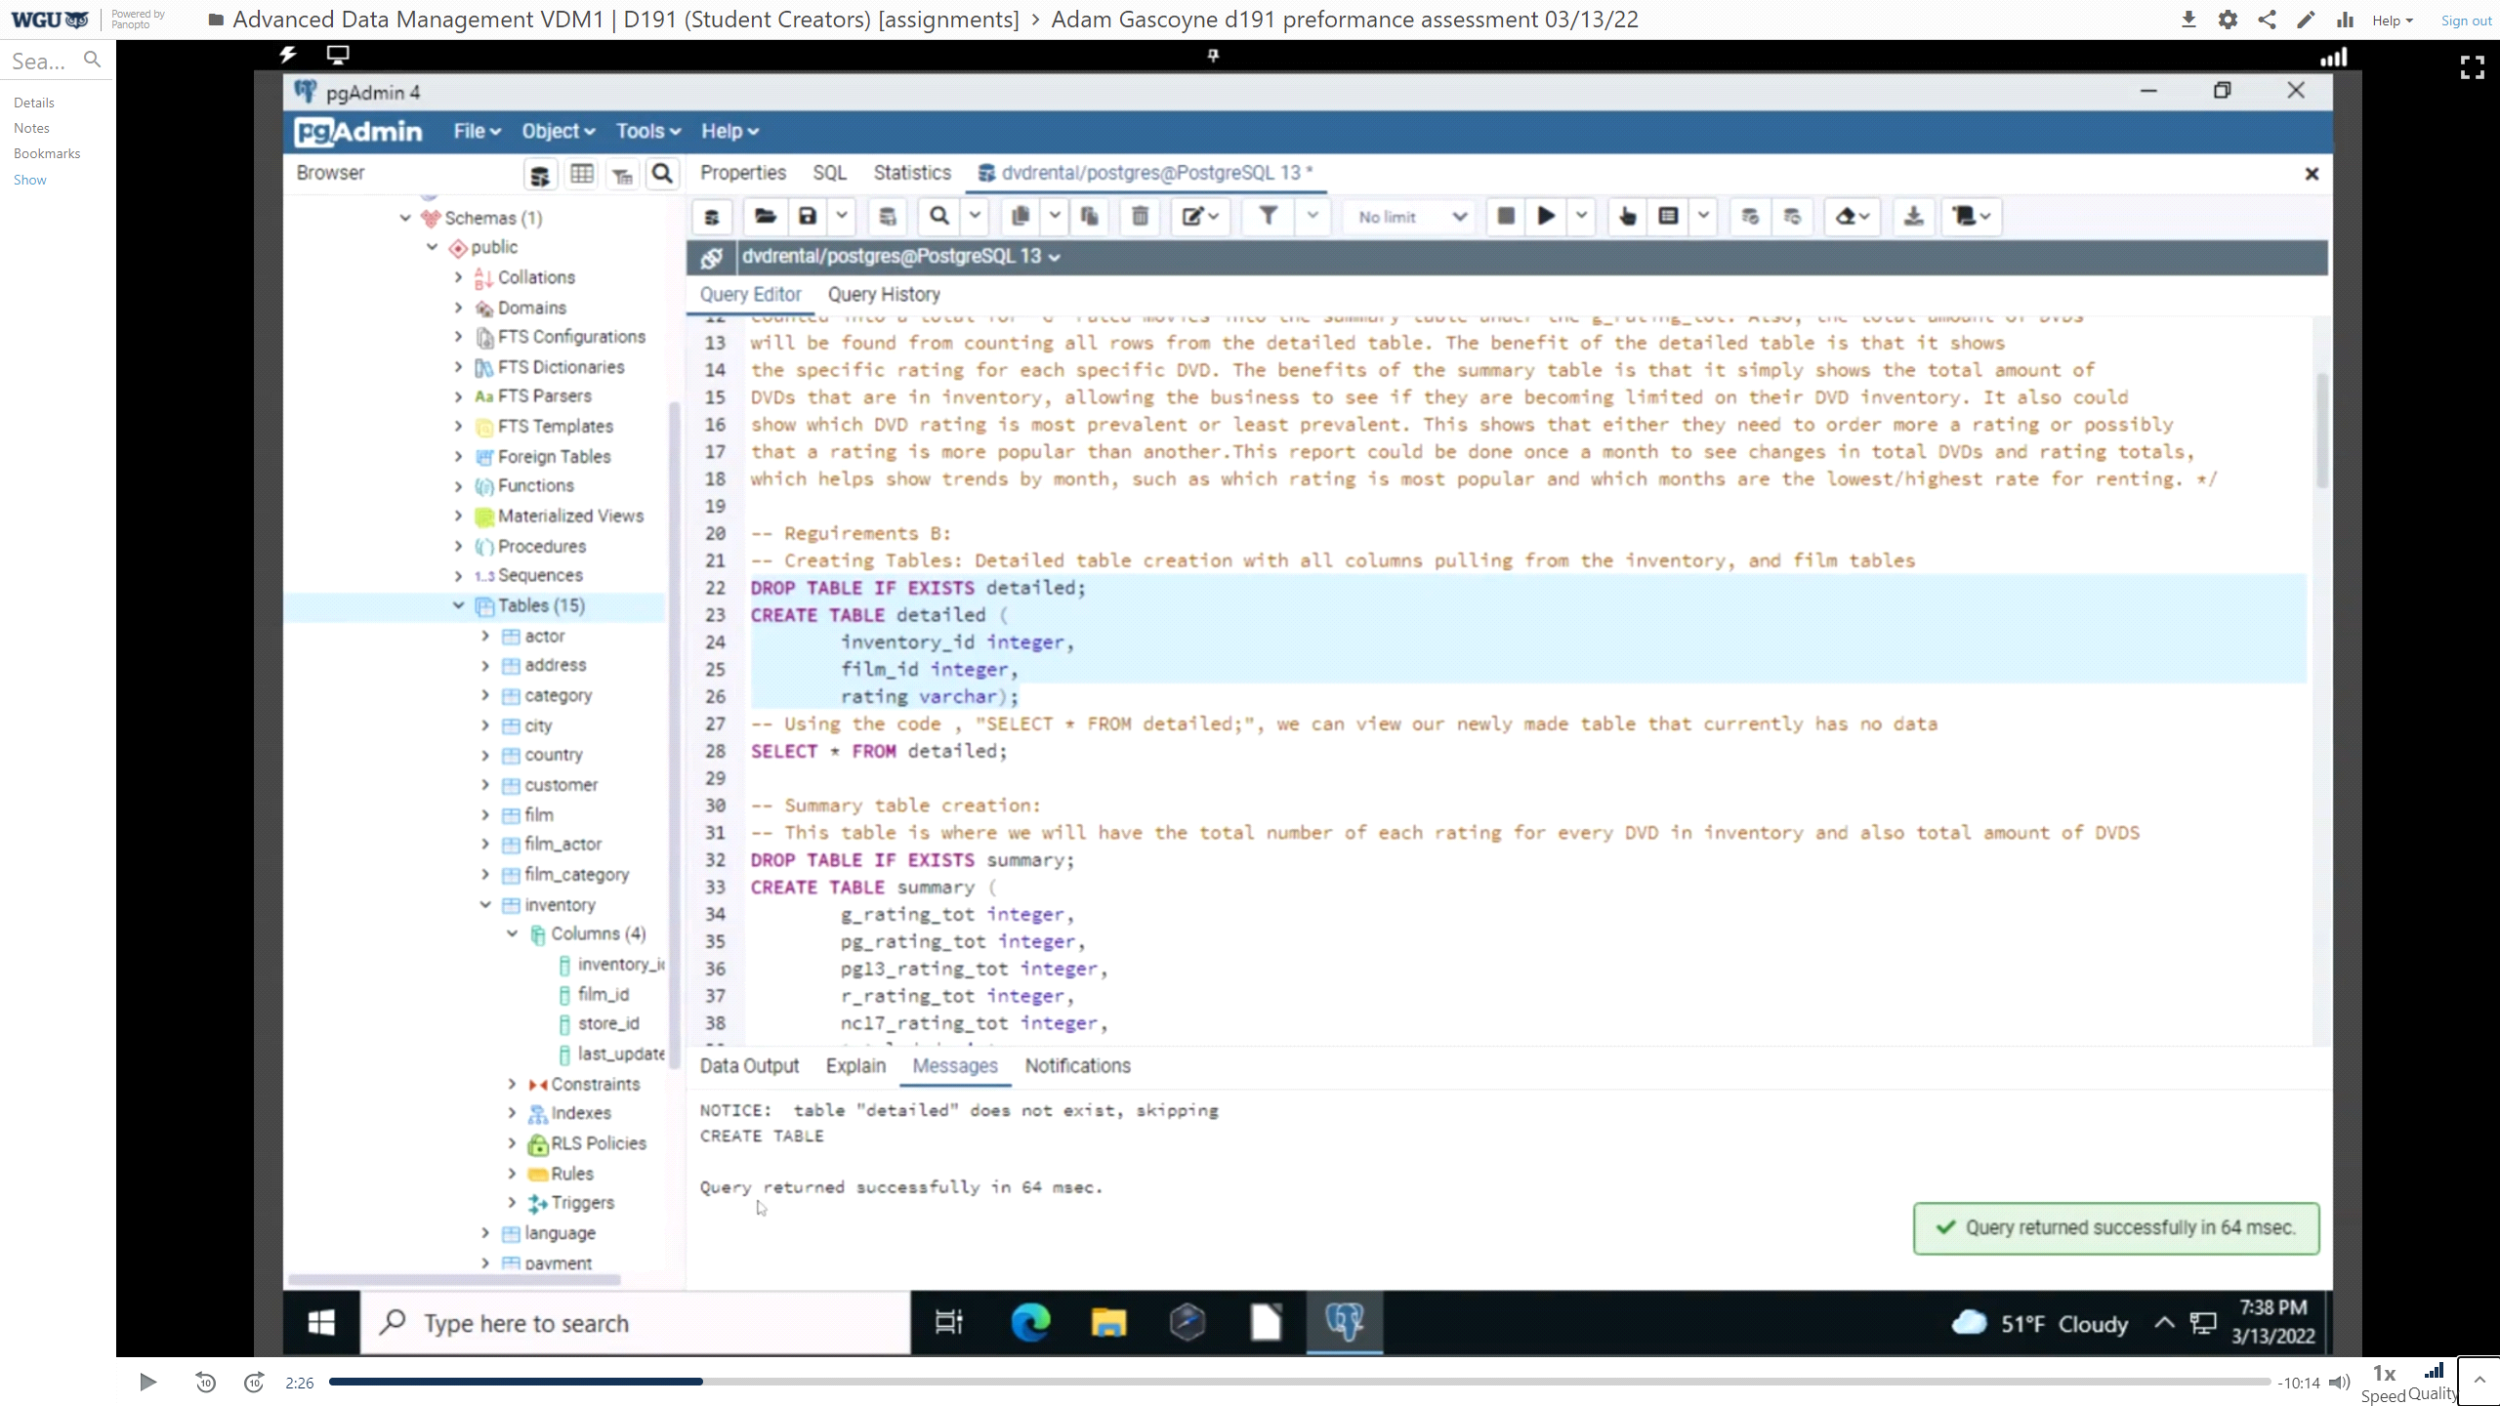

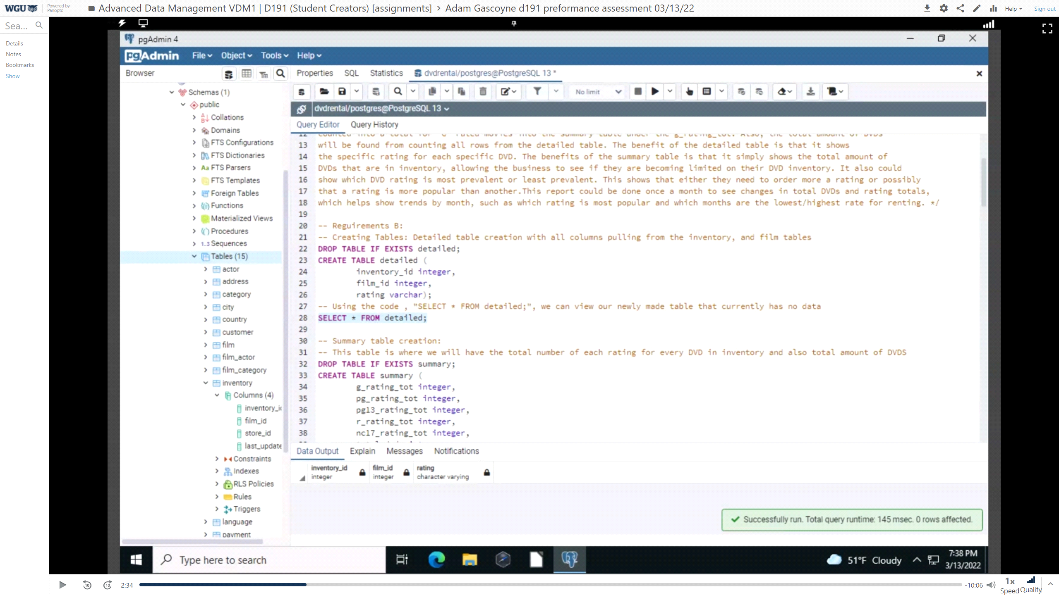

This code creates a new table called “summary” and if it already exists, deletes it, and creates it again. The first picture shows successful code. The second picture shows the actual table with the columns of g_rating_tot, pg_rating_tot, pg13_rating_tot, r_rating_tot, nc17_rating_tot, and total_dvds using the “SELECT * FROM summary;” code.

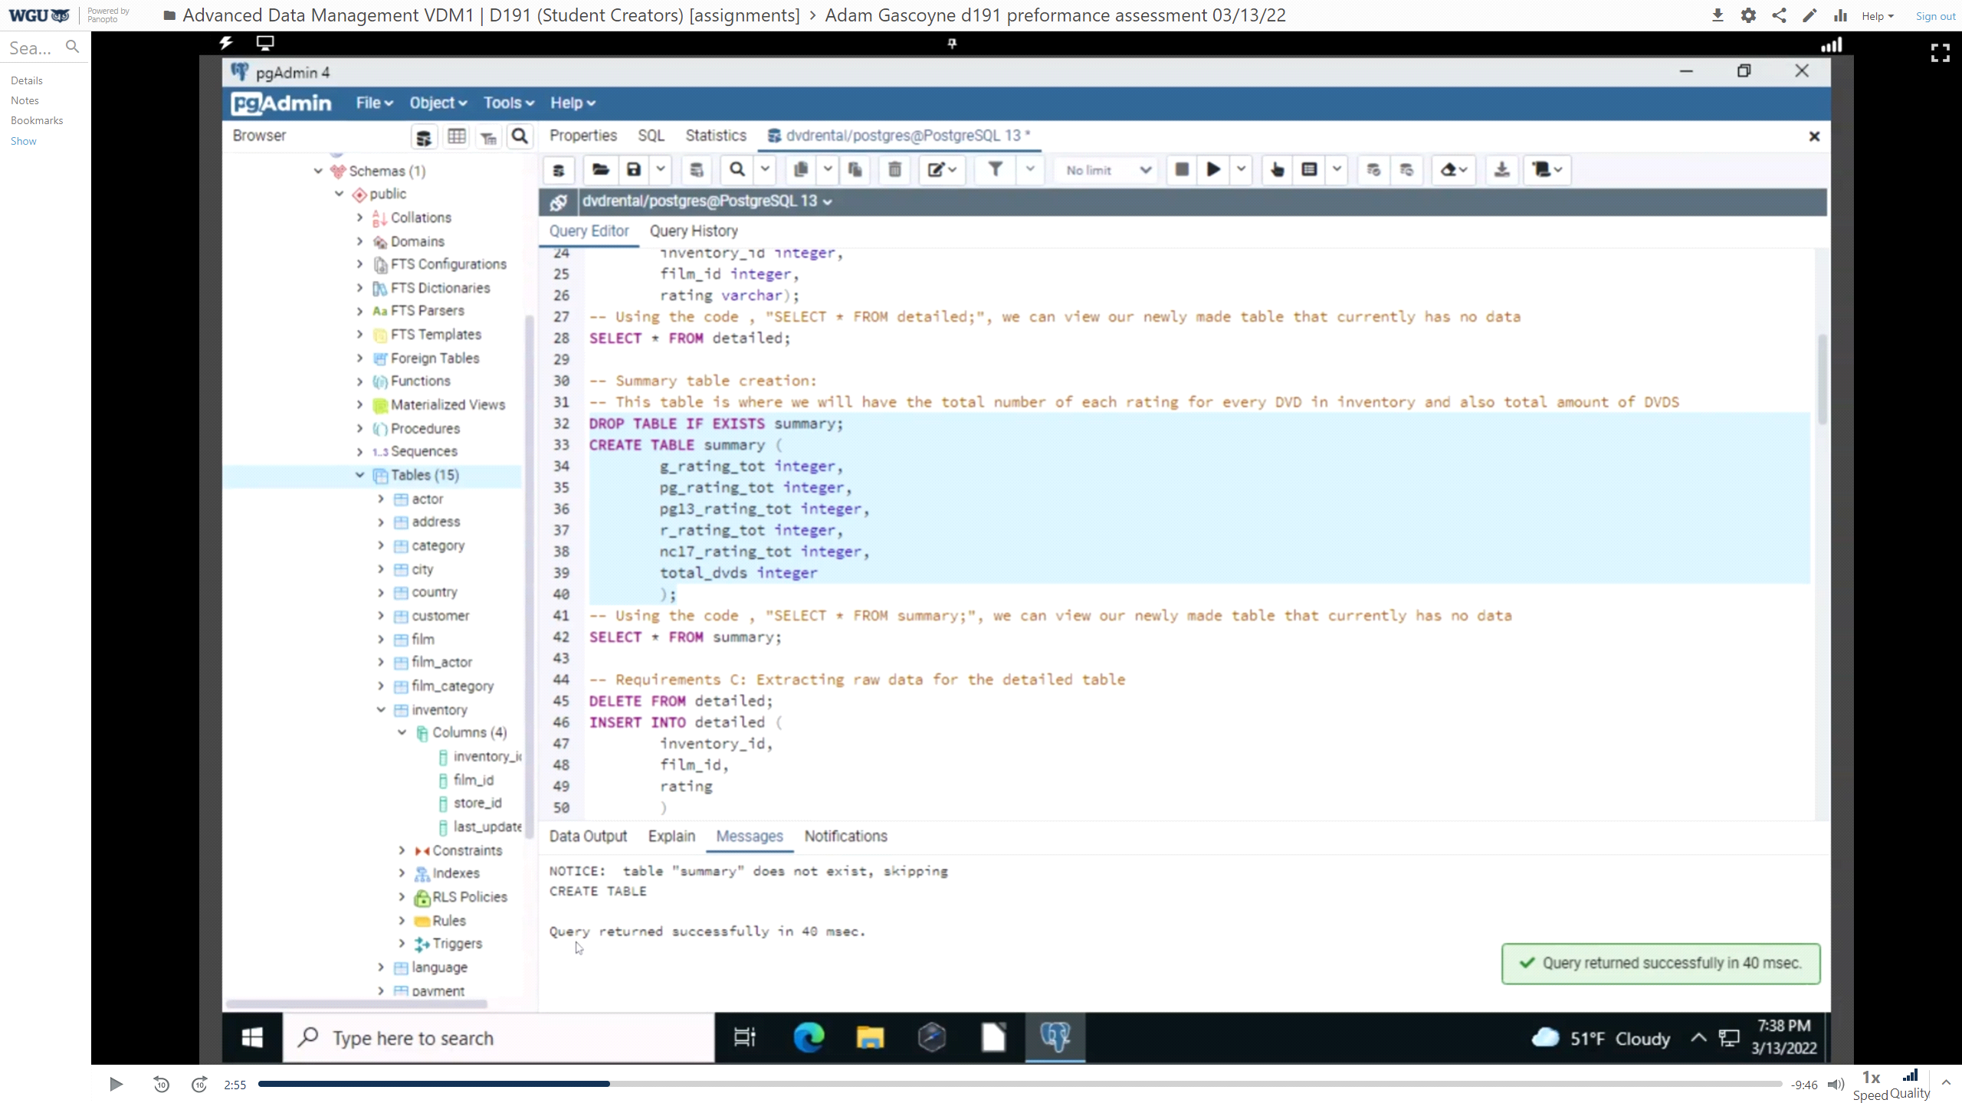

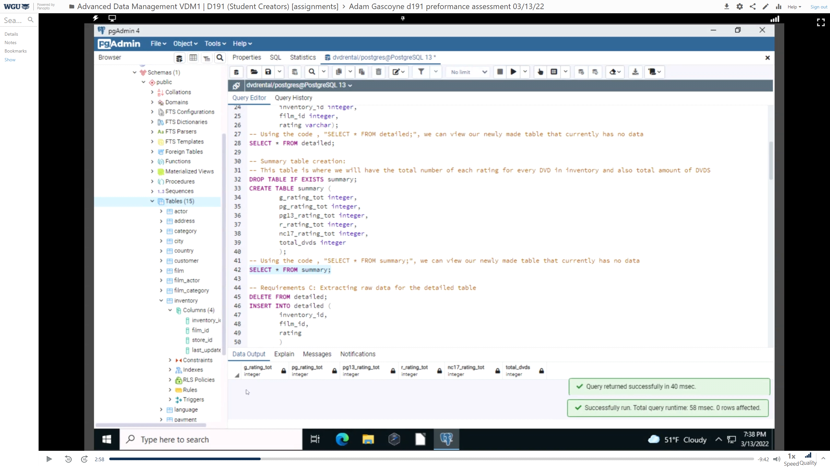

This picture shows that the two new tables were added to the table tab.

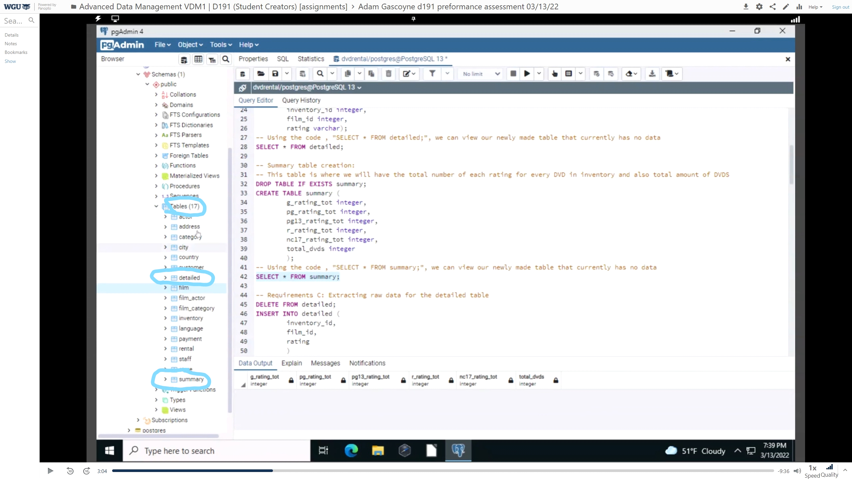

**C:** To populate the "detailed” table we will need the data from the inventory and film table. We will be using the columns “film_id” and “rating” from the “film” table, and the “inventory_id” from the “inventory” table. We used inner join on the “film_id” as it shows up in both tables. This will not allow duplicating the film IDs when populating the data into the “detailed” table. To transfer the data, we will be using an “INSERT” on the selected columns (“inventory_id”, “film_id”, and “rating”) from the “detailed” table. The first picture will show a successful insertion. The second picture will show a populated “detailed” table with the columns “inventory_id”, “film_id”, and “rating” ordered by “rating”. The third picture is the last row showing the highest “inventory_id” when the code “SELECT * FROM detailed” is ordered by “inventory_id” with the code “ORDER BY inventory_id;”

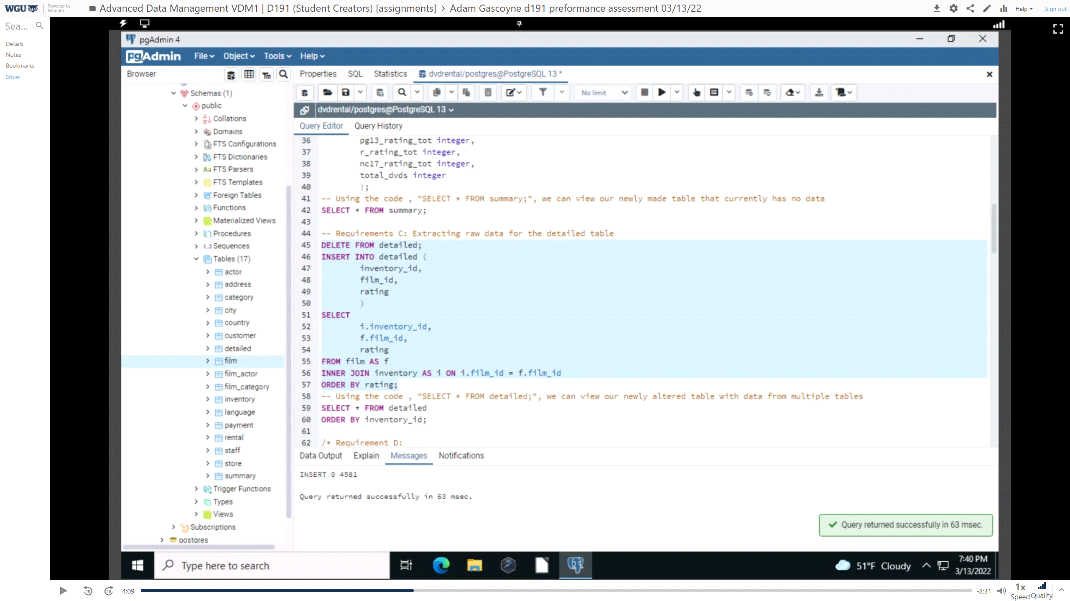

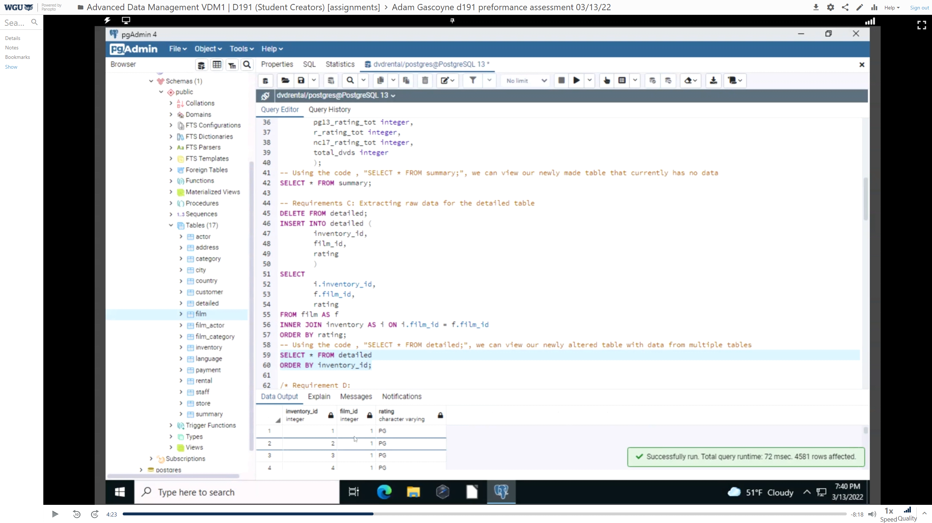

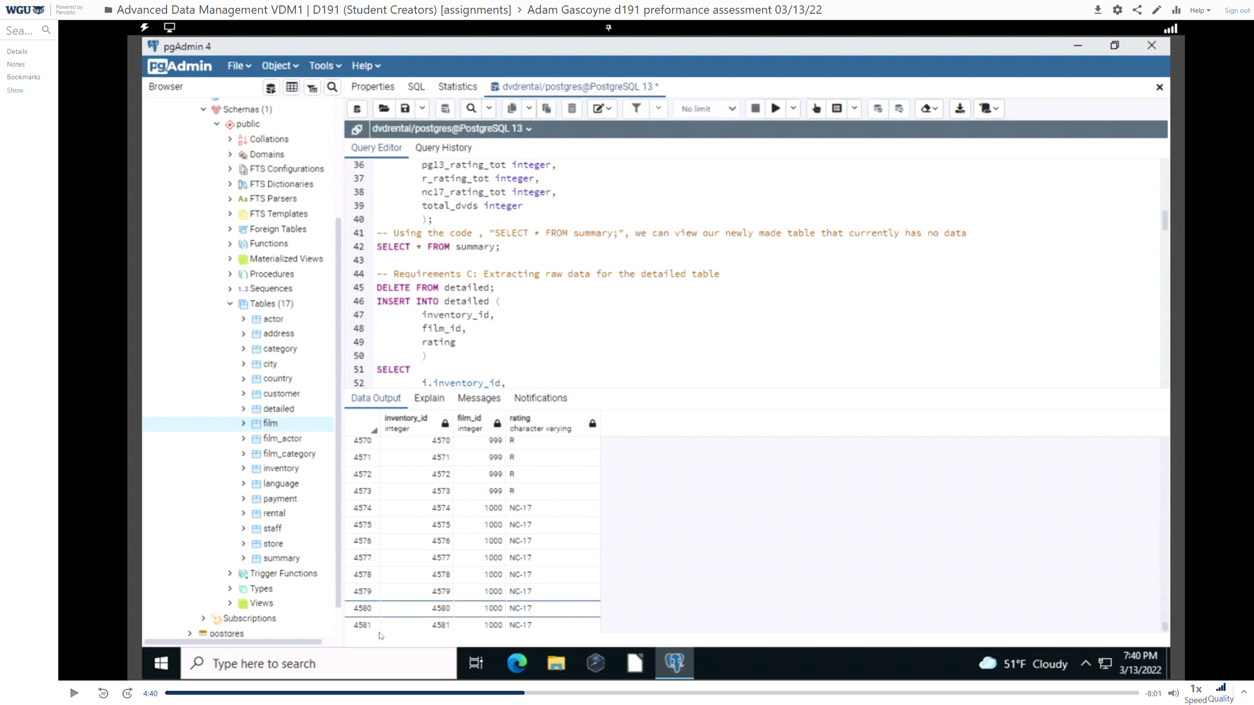

**D:** Using this code we will be able to populate the “summary” table with the data from “detailed”. This code will iterate through the rating column of the “detailed” table and total up the individual ratings for each DVD and total how many DVDs are in that table. For example, while iterating through the column “rating” in “detailed” we will find every instance of ‘G’ and total it into the column “g_rating_tot” in “summary”. After, this occurs for all ratings, the code “COUNT(*)” will total every row in “detailed” populating the “total_dvds” column in “summary”. The data was transformed from a VARCHAR to an INT data type. This picture shows the successful insertion and transformation of data into the “summary” table.

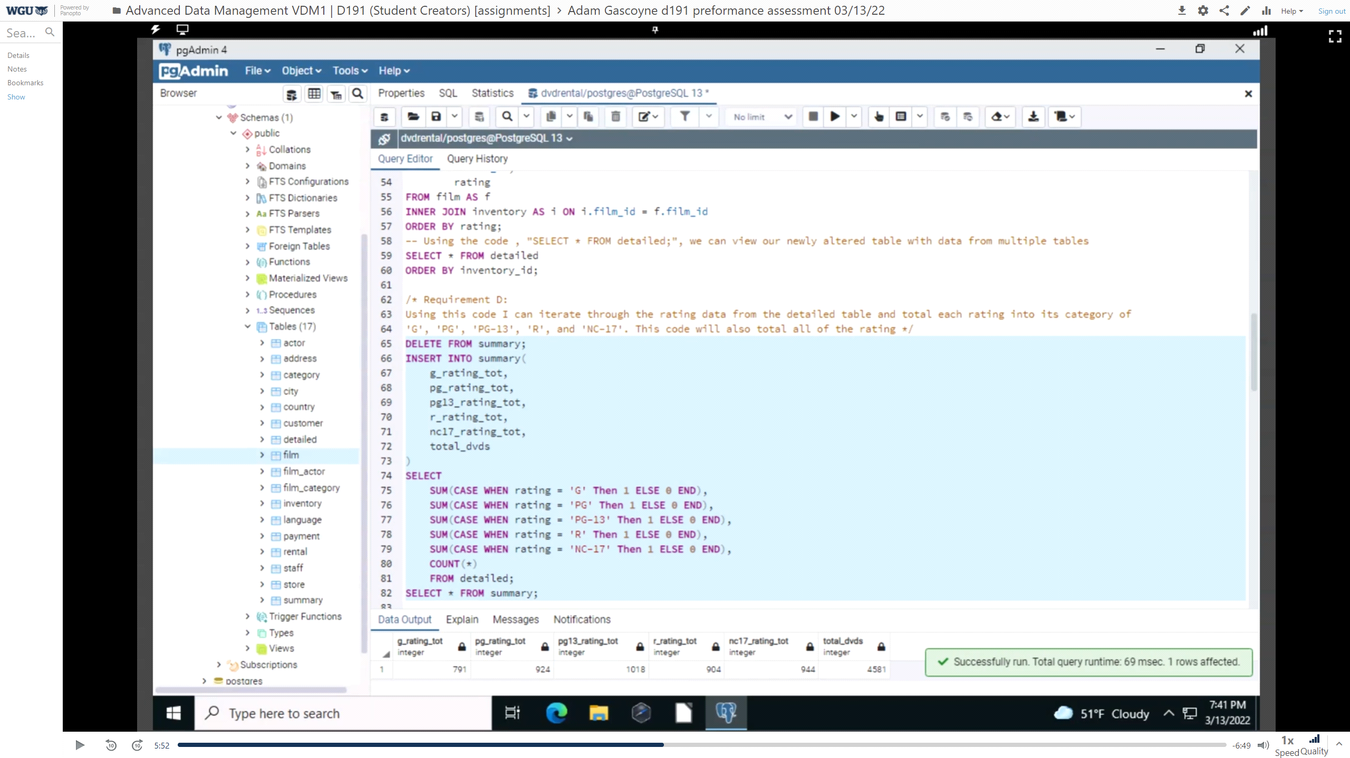

**E:** I created two triggers, one to execute a trigger on “inventory” and another on the “detailed” table. I did this as it seems to make more sense to want to “INSERT” into “inventory”. You can directly “INSERT” into “detailed” to activate the trigger if you want so you can fulfil the requirement directly using code like this “INSERT INTO detailed VALUES (V1,V2,V3)”. This code will be creating a trigger that will execute whenever there is an insert into the “inventory” table. We use the code “INSERT INTO inventory VALUES (4592, 1000, 2, '2006-05-25 10:09:12');” to insert a new row into the “inventory” table and execute the trigger “inv_table_change”. The trigger will execute and run the function “update_detailed_trigger_function()”. This function has the purpose of calling the procedure “update_detailed_data()”. Calling this procedure automatically does an “INSERT” on “detailed”. The first picture shows the successful code for the function “update_detailed_trigger_function()”. The function must be run before the trigger is activated or it will not show a successful run. The second picture shows the trigger execute successfully. The fifth picture shows the “detailed” trigger successfully running.

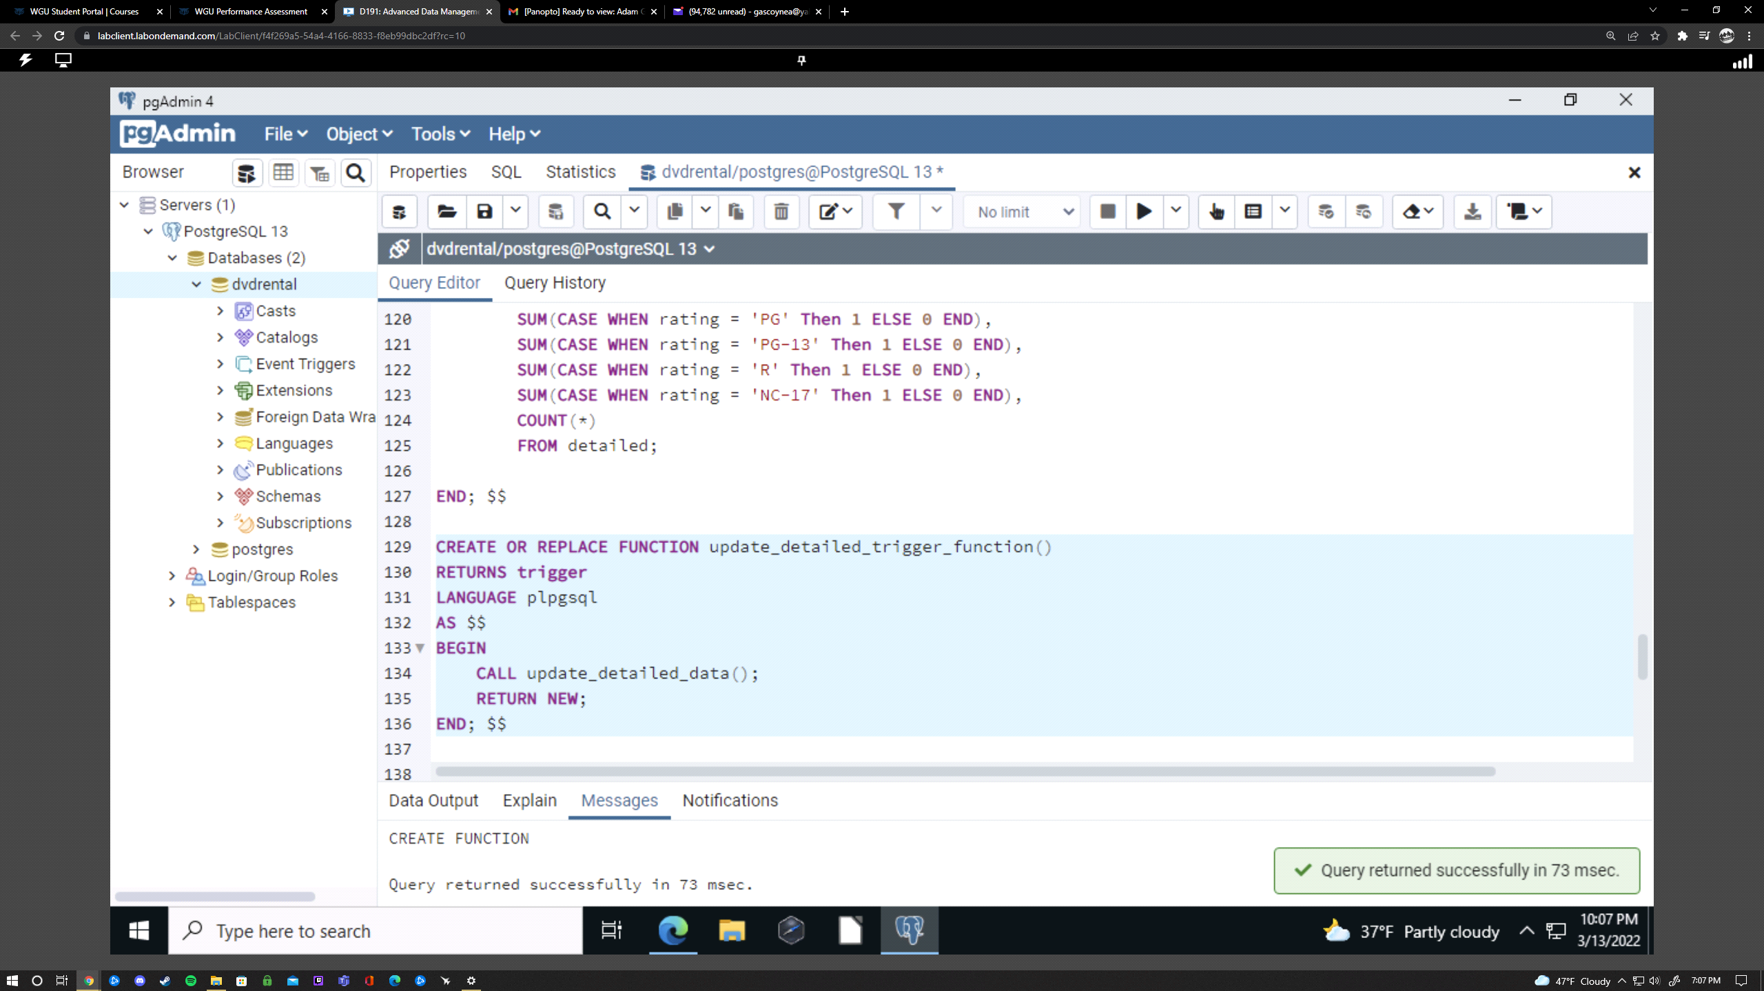

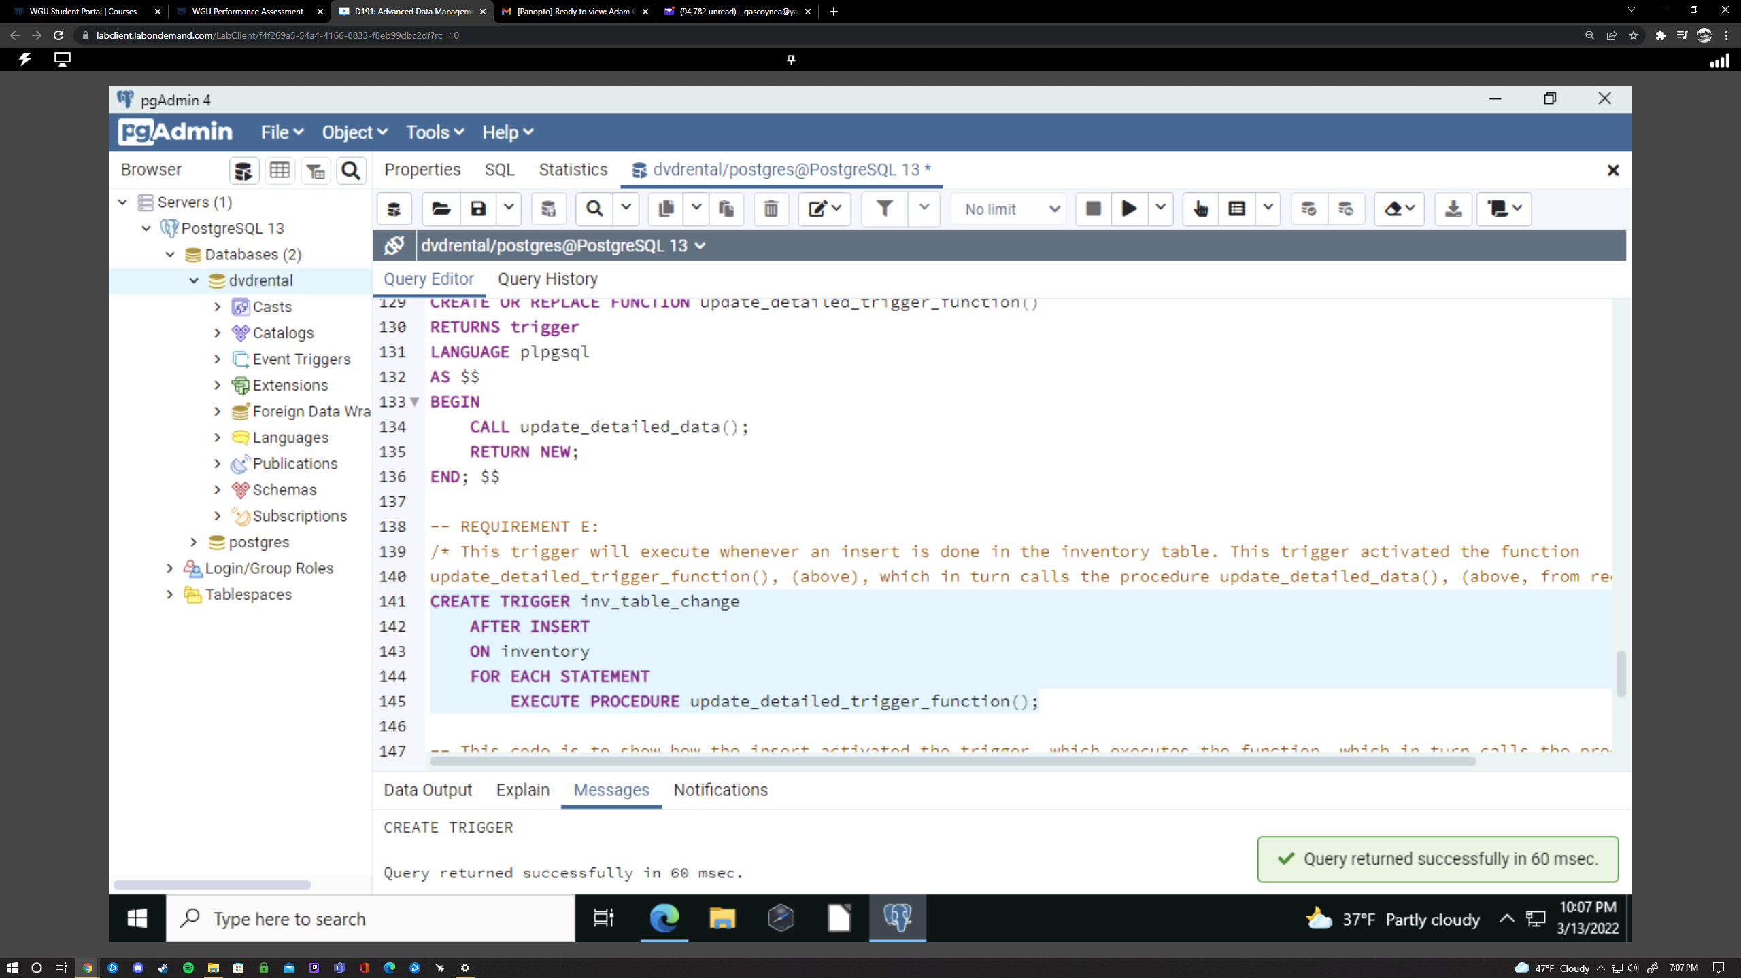

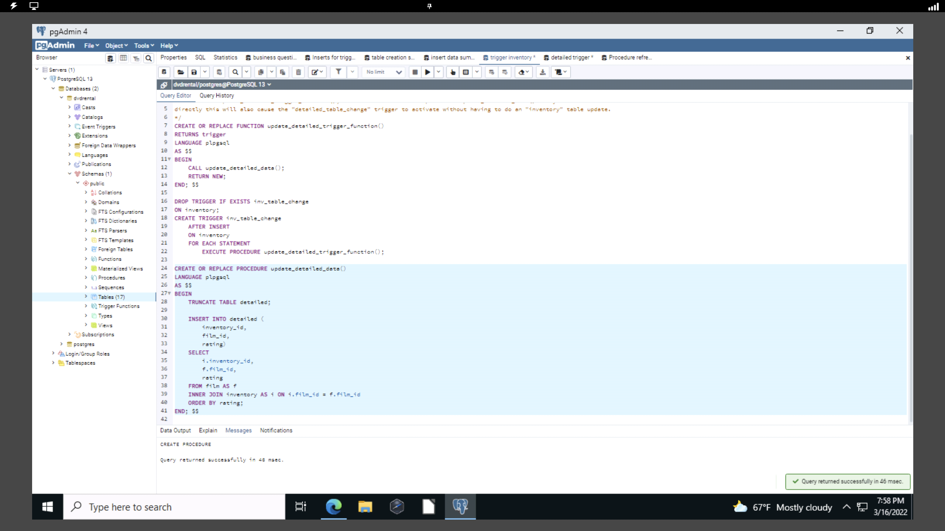

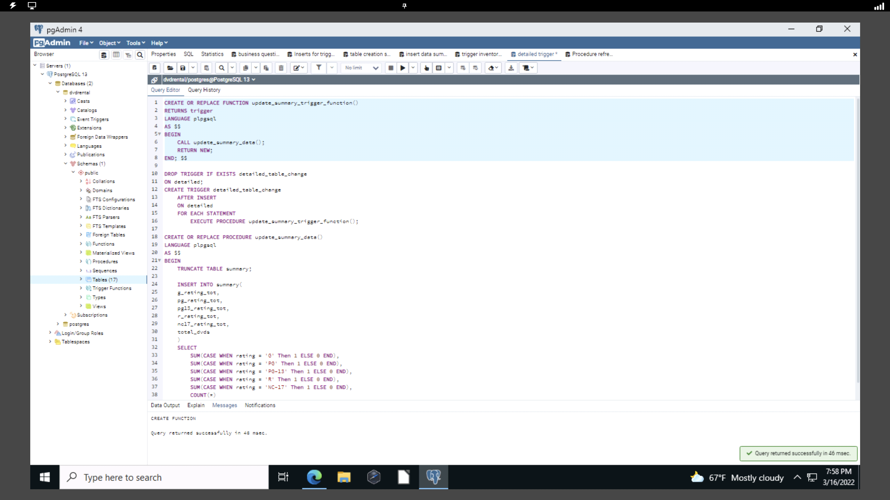

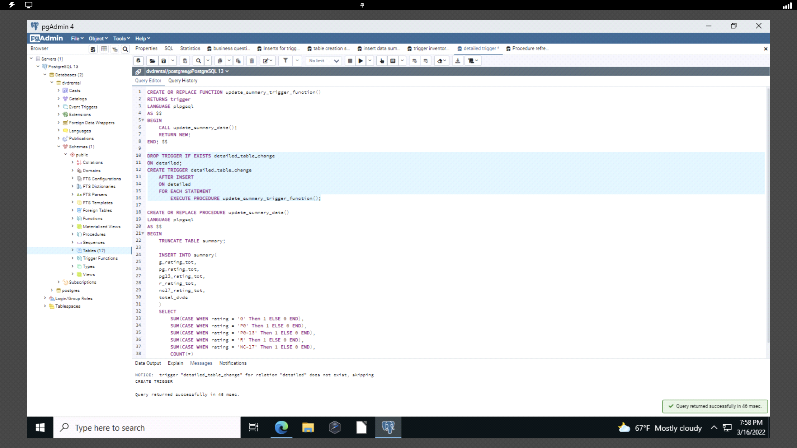

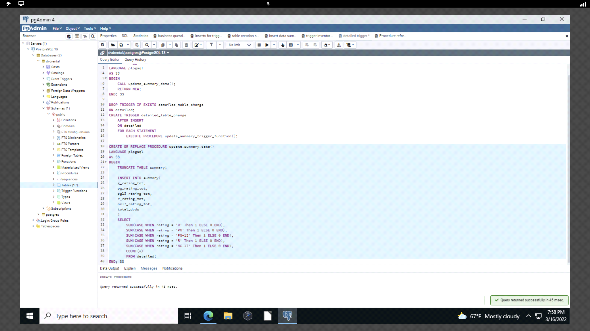

These pictures will show the triggers working when activated with an “INSERT”.

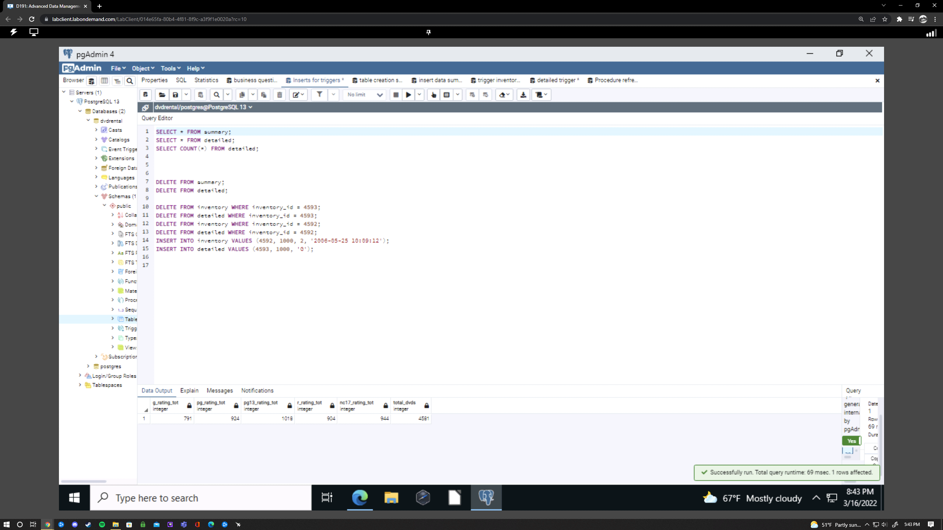

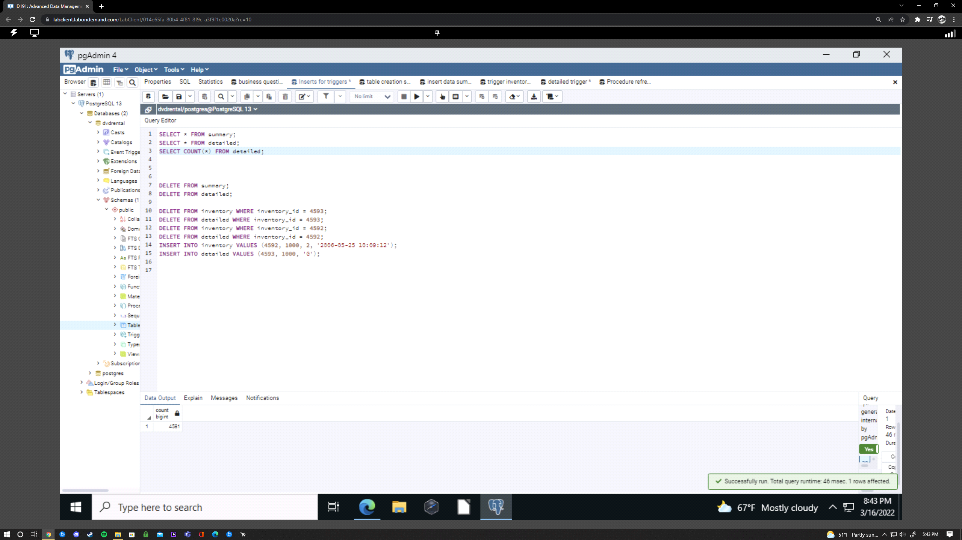

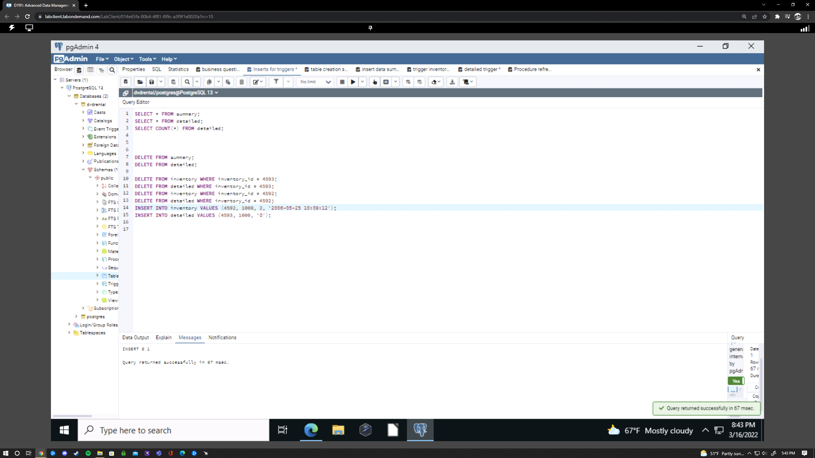

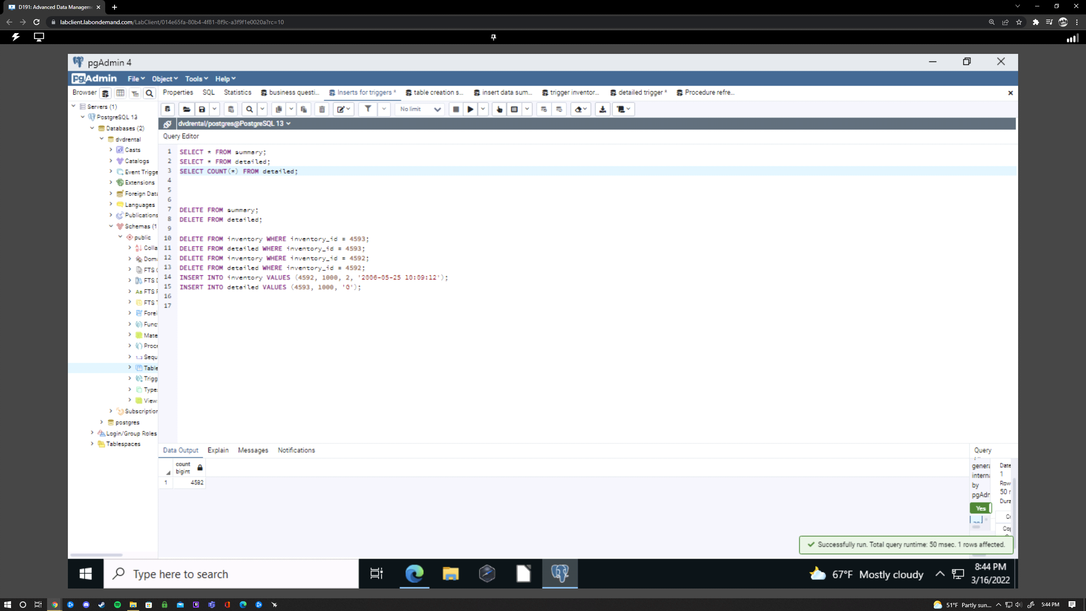

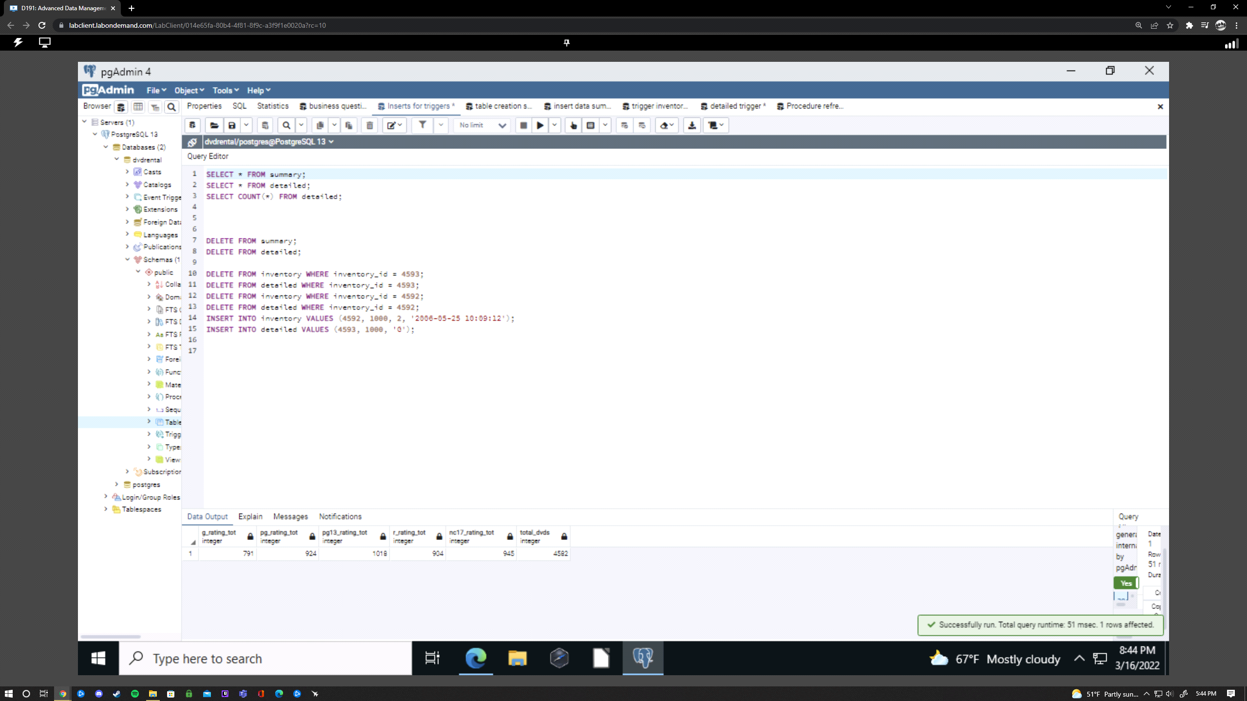

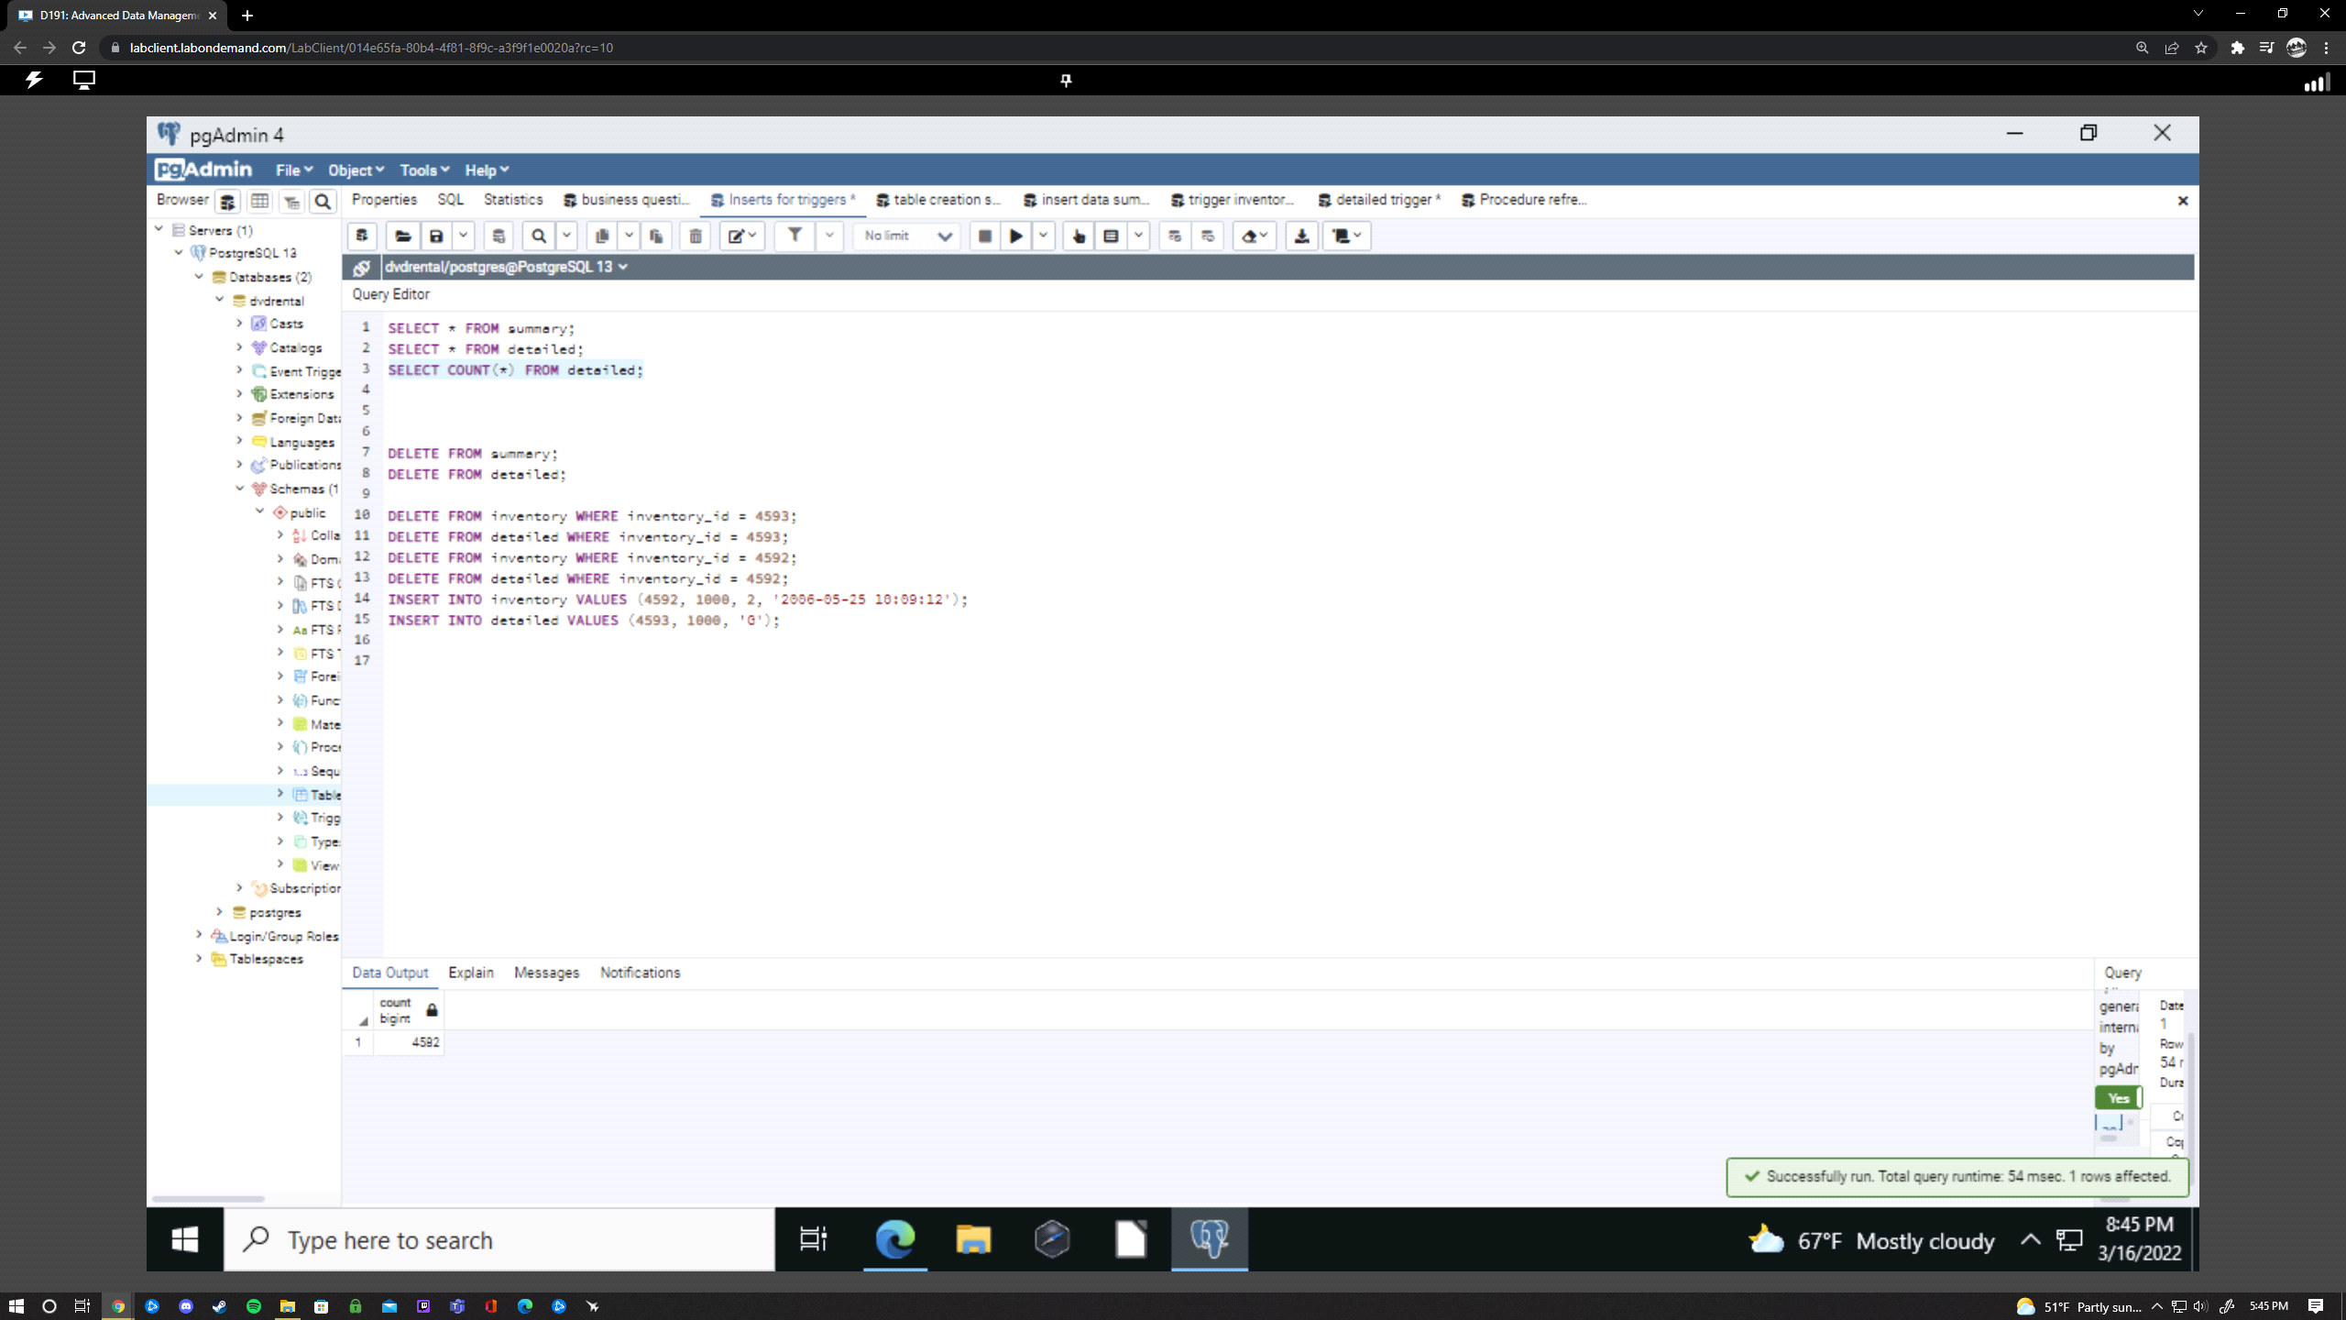

**F:** When this procedure is called the data in the detailed table and summary tables are refreshed and updated. First, both tables are truncated, using “TRUNCATE TABLE detailed;” and “TRUNCATE TABLE summary;” which removes all data from both tables. Secondly, the new data is updated into the “detailed” table using the same code we initially used when first populating this table. Last, the “summary” table is updated using the refreshed “detailed” table. This is also updated using the same code that initially populated the “summary” table. This procedure should be run once a month, preferably at the same time every month such as at the beginning, if it is consistent, this technique will make the most accurate data for analysis. As stated, this could be run at any point so if you know there will be a huge influx of DVDs into the inventory you may run it just to note the huge change in volume. Whoever oversees the inventory database should be the one running this monthly. The first picture shows the procedure successfully running.

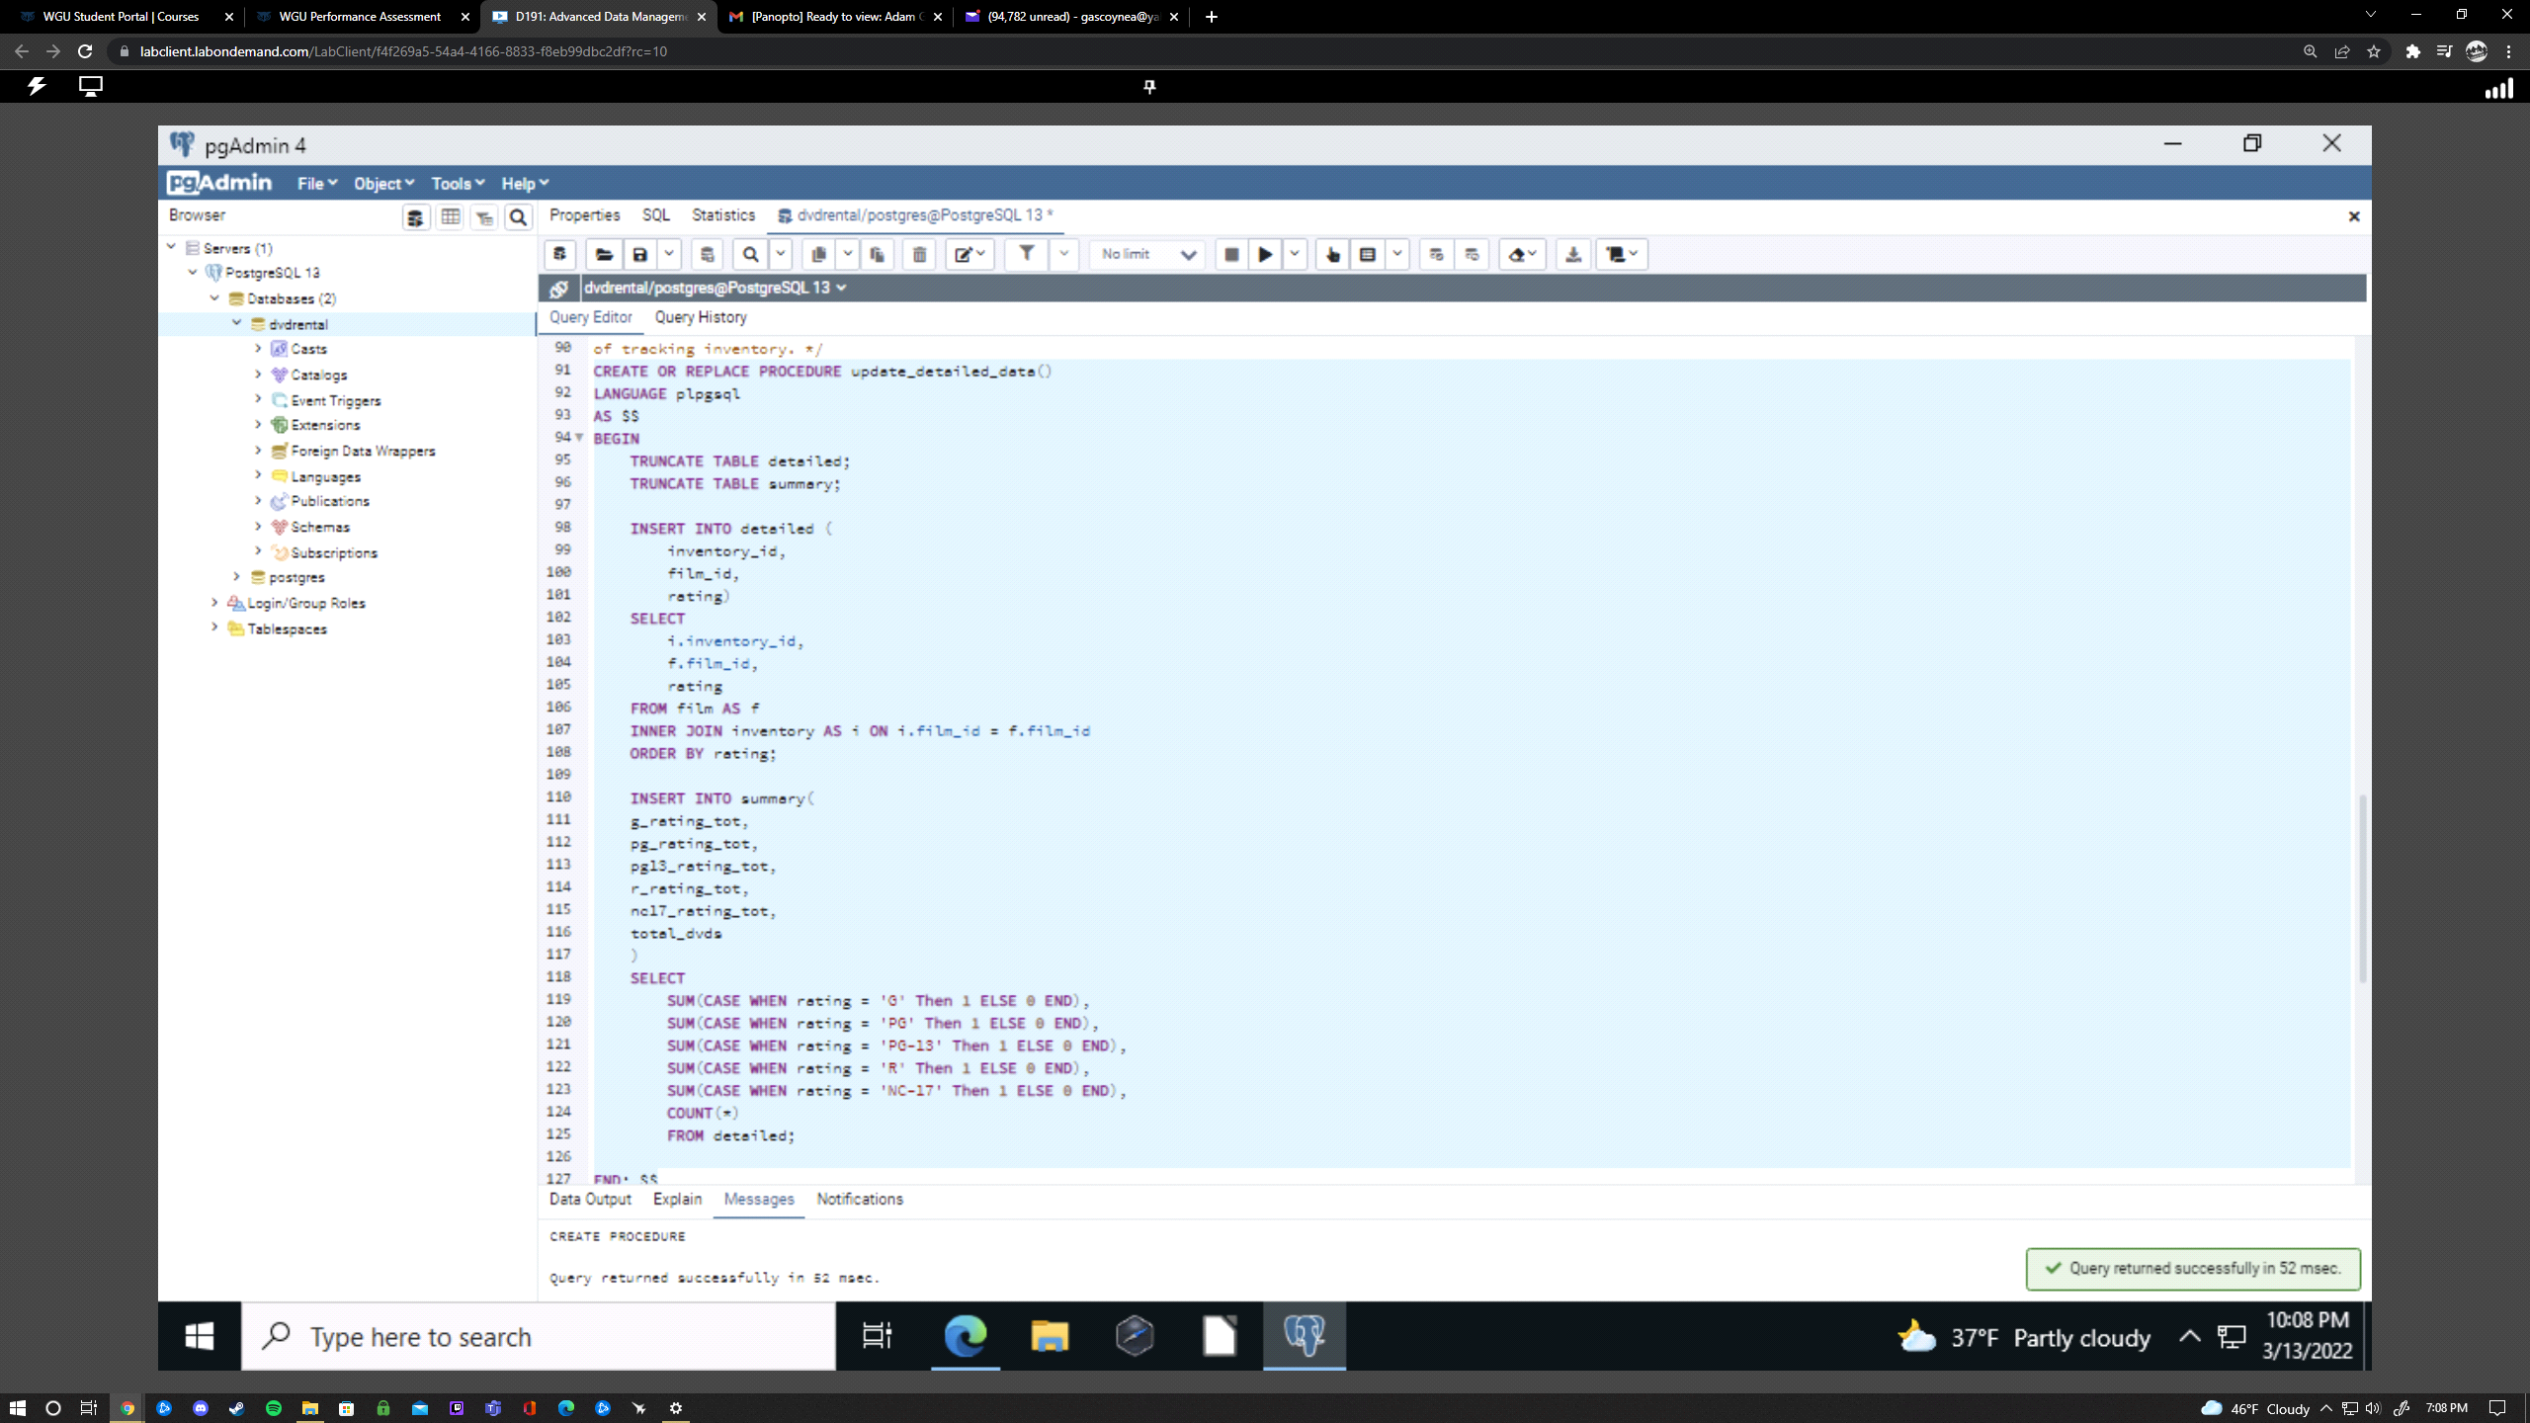

Because PostgreSQL doesn’t have a scheduler innately, we will have to use a third-party source such as Linux crontab, Agent pgAgent, or Extension pg_cron. For this situation we will use Agent pgAgent which needs to be installed manually in pgadmin4. Firstly, you will need to create the plpgsql language. Secondly, this is when you’d directly install pgAgent. After that you will need to create a pgAgent extension. This is all done in PgAdmin4. The extension will populate the functions and tables to be used by the pgAgent operation. To get into more depth on Agent pgAgent click this link which is also below in under sources. “<https://severalnines.com/database-blog/overview-job-scheduling-tools-postgresql>”

**Sources:**

PostgreSQL Tutorial. (n.d.). *PostgreSQL Tutorial*. PostgreSQL tutorial. Retrieved March 16, 2022, from <https://www.postgresqltutorial.com/>

I used postgresqltutorial.com for general information and refreshers on syntax.

Group, P. S. Q. L. G. D. (2022, March 17). PostgreSQL. Retrieved March 16, 2022, from <https://www.postgresql.org/>

Just like postgresqltutorial.com I used postgresql.org for general information and refreshers on syntax as well.

Dias, H., & Dias, H. (2020, February 3). *An overview of job scheduling tools for postgresql*. Severalnines. Retrieved March 16, 2022, from <https://severalnines.com/database-blog/overview-job-scheduling-tools-postgresql>

I used this link to learn about schedulers that can be implemented in this project.